Virtual Reality for Traffic Safety Education in Elementary Schools

Vera Yuli Erviana¹, Oktomi Wijaya^{2*}, Dwi Sulisworo¹, Rusydi Umar³
¹Faculty of Teacher Training and Education, Universitas Ahmad Dahlan, Yogyakarta
²Faculty of Public Health, Universitas Ahmad Dahlan, Yogyakarta
³Faculty of Industrial Technology, Universitas Ahmad Dahlan, Yogyakarta

*Corresponding Author: E-mail: Oktomi.wijaya@ikm.uad.ac.id

ARTICLE INFO | ABSTRACT
Manuscript Received: 11 Oct, 2024  Revised: 14 Jan, 2025  Accepted: 25 Jan, 2025  Date of Publication: 04 Feb, 2025  Volume: 8  Issue: 2  DOI: 10.56338/mppki.v8i2.6598 | Introduction: Traffic safety education needs to be taught to children at an early age. Traffic safety training for children in a real-world environment has several challenges and difficulties. Letting children practice in the real traffic environment will expose them to potential hazards. The purpose of this study was to develop media promotion for traffic safety education using a virtual reality (VR) for elementary school students.  Methods: This research design used the 4-D model (define, design, develop, and disseminate). Data were collected qualitatively by conducting FGDs and interviews, while quantitative data were collected by distributing questionnaires.  Results: The traffic safety VR media tested 4 scenarios, namely: driving equipment, traffic lights, how to cross the road, and walking etiquette. The validity test results show that VR traffic safety is feasible to be used as learning media for elementary school students. Students and teachers responded positively to this media. The advantage of this media is that it is fun and interactive for children.  Conclusion: Media promotion for traffic safety education using virtual reality can be applied in a wider scope in other elementary schools. Future research can develop more complex scenarios such as cycling, crossing railroad, and many more. The use of virtual reality (VR) in traffic safety training provides an immersive and interactive learning experience, which is more engaging compared to traditional methods.
KEYWORDS
Development;
Media Promotion;
Traffic Safety Education; Virtual Reality;
Elementary Schools
Publisher: Fakultas Kesehatan Masyarakat Universitas Muhammadiyah Palu

INTRODUCTION
Traffic safety around the world remains a major concern. The 2018 global status report on road safety, launched by WHO in December 2018, highlighted that the number of road traffic deaths each year has reached 1.35 million. Road traffic crashes are now the leading killer of children and young adults aged 5-29 years (1). The same concern also exists in Indonesia. Traffic accidents in Indonesia show a concerning trend. After a decrease in the number of accidents from 116,411 in 2019 to 100,028 in 2020, the number rose again to 103,645 in 2021 (2). The death rate from traffic accidents per 100,000 population is around 12 people. This is very high compared to neighbouring countries such as Singapore (4.8) and Australia (5.2) (3).
Yogyakarta is one of the major cities in Indonesia. Geographically, Yogyakarta is a potential area for traffic movement on the southern route of Java Island. The route includes national roads. With these conditions, the movement of road traffic in Yogyakarta from year to year is quite high and tends to increase. Thus, the number of accidents is also predicted to increase along with the increase in traffic movement. Based on data from the Yogyakarta Police Traffic Unit, during the 2017-2020 period, there were 2,554 traffic accidents (4). Meanwhile, according to the 2018 Basic Health Research (Riskesdas) data, Yogyakarta has an accident rate of 31%, the majority of victims are children (17.4%) (5).
Children are particularly vulnerable to traffic accidents because they are still developing physically and cognitively and lack the experience and awareness needed to navigate traffic safely (6). Study (7) found that the main causes of road traffic accidents involving children are: walking in the wrong lane, and crossing the road in a dangerous manner. Meanwhile, study (8) found that the most common cause of road accidents involving children as pedestrians was sudden entry into the centre of the road. Another study identified that inadequate play environment factors can increase the risk of accidents (9). Study (10) found that the main causes of road traffic accidents among children in Northwest India were due to their lack of awareness of traffic rules and the absence of pedestrian crossings in many areas. Research by (11) investigated traffic accidents involving children in Japan, highlighting that a large number of accidents occurred on single-lane roads without barriers. Meanwhile, the main factors contributing to the severity of injuries in child road traffic crashes are the lack of use of safety equipment in driving, such as seat belts for car passengers and helmets for cyclists and motorcycle riders (12).
The main factors contributing to the high rate of traffic accidents in Indonesia include human error, poor vehicle condition, inadequate road maintenance, and environmental factors. Human error is identified as the main cause of traffic accidents (13). Due to the significant impact of human factors as the cause of accidents, education plays an important role in traffic safety. The role of education in traffic safety is to increase knowledge, change attitudes, target behaviour change, and ultimately reduce road deaths and injuries (14–18). A study in Shandong Province, China found that traffic safety education can improve motorists' knowledge and awareness (15). In Vietnam, traffic education has a positive impact on confidence, awareness, independence, and driving skills (16).
Traffic safety education needs to be taught early to children as the early years are a critical time to introduce key concepts for lifelong learning (19). Traffic safety education in the early childhood curriculum can help children form realistic perceptions and theories about safe and unsafe actions (18,20–22). Research by (23) explored the impact of traffic safety education on the road behaviour of Spanish children and adolescents, and revealed that knowledge of traffic rules is important in producing safer behaviour. Meanwhile, a study by (24) in Malaysia evaluated the effectiveness of traffic safety education interventions in primary schools in Malaysia from 2007 to 2010, targeting children aged 8 and 10 years. The findings showed a significant reduction in road crashes in the areas where the intervention was implemented.
Teaching traffic safety education to children requires innovative learning methods that attract their interest. One of the most widely used learning methods is game-based learning. Game-based learning can improve knowledge of road rules and safety, showing significant improvements in participants' knowledge acquisition and retention (25). Games can also provide an immersive and engaging learning environment, which can increase interest in the subject matter and meet learners' needs more effectively than traditional methods. Moreover, game-based learning can bridge gaps in knowledge due to differences in age, prior experience, or beliefs, making it a versatile tool for education. Furthermore, games can improve cognitive achievement by providing authentic and engaging learning experiences in a safe environment (26).
Traffic safety training for children in a real-world environment has several difficulties. Allowing children to train in an actual traffic environment exposes them to potential hazards (27–29). To overcome this problem, traffic safety training based on Virtual Reality (VR) technology seems to be a promising solution. In VR, the real-world environment is replaced by a realistic and safe virtual environment. Previous studies have confirmed the great potential of this approach (30). VR has the potential to facilitate knowledge acquisition, content comprehension, effective communication, and problem-solving skills (31,32). The implementation of fully functional virtual environments facilitates learning among people of different ages, and is safer than real-world experiences (33). VR is also cost-effective and able to reduce potential risks (34).
Media promotion for traffic safety education using VR game have the potential to improve knowledge and recognition of dangerous situations, and how to properly handle these situations by providing a safe and immersive environment where users can practice road activities in a variety of dangerous situations (26). Several studies have been developed in traffic safety education using VR. For example (35) developed the educational "Woodlands," a VR game designed to teach road safety to children in Ireland. The game combines theoretical and practical road safety skills, emphasising safe road crossing habits. The game received positive feedback from players. Next (36) designed an interactive visual system to improve school children's road crossing behaviour. They confirmed an increase in children's road crossing knowledge after participation. Another study (37) evaluated an educational game designed to teach road safety to children aged 7 to 9, using an iPad-based platform and virtual reality. The game received positive feedback from the children, with the majority enjoying the game. The VR game showed significant improvement in terms of road crossing skills, indicating that immersive devices can effectively enhance traffic safety education.
Yogyakarta showed an increase in the incidence of traffic accidents among children due to lack of knowledge and unsafe behaviour on the road (38). An effective intervention strategy that can be done for behaviour change is through safety education approach (39,40). The use of VR media has potential advantages in traffic safety education when compared to teaching in real traffic that can endanger children. The use of VR in traffic safety education provides an immersive and interactive learning experience, which is more engaging compared to traditional methods. Currently, there is limited research in the development of traffic safety education media using VR for elementary school children in Indonesia. The purpose of this study was to develop a media promotion for traffic safety education using virtual reality for elementary school students.

METHOD
The research method used in this study is research and development (RnD). RnD is a research method used to make products and test the effectiveness of these products (41). The product developed in this study is media promotion for traffic safety education using virtual reality for elementary school students. The research design used a 4-D model approach (42) as presented in figure 1.

Figure 1. Research design with 4-D model

The stages in the 4-D model consist of: define, design, develop, and disseminate. At the define stage, problems related to traffic safety in schools were identified and the need for traffic safety education development was identified. The design stage is carried out by selecting the educational media to be used and developing learning media. At the development stage, an expert validity test is carried out with experts in the fields of content, media, and language. At the dissemination stage, feasibility testing was conducted with teachers, and pilot test with students to get feedback.
The research data were collected through qualitative and quantitative approaches. Qualitative studies were conducted to identify the problems and needs for the development of traffic safety education for primary school students in Yogyakarta City with principals, teachers, parents, and security, as well as interviews to obtain feedback from students and teachers. Focus group discussions (FGDs) and interviews were conducted to collect data. The research informants were taken using purposive sampling technique. The informants in this study were 31 people consisting of principals, teachers, parents, and students from 5 elementary schools in Yogyakarta City. The schools selected in the study were with the criteria of elementary schools located on the edge of the highway with heavy traffic. The selected schools consisted of public and private schools. The quantitative study was carried out through the distribution of questionnaires in the validity test with experts. The expert criteria are as follows: 1) the criteria for media experts are: able to assess the aesthetics of the display of teaching materials, able to validate learning media products, mastering learning media, 2) the criteria for content experts are traffic safety experts, while, 3) the criteria for language expert is to have in-depth knowledge of linguistics through scientific studies. In addition, language experts must also have a certificate of proficiency in Indonesian language. The experts in this study validity test were: content experts from the Indonesian National Police, media experts from informatics engineering experts, and Indonesia language experts from Indonesian Language study programme lecturers. The expert validation questionnaire consists of 3 questionnaires, namely: media, material, and language validation questionnaires. The learning media expert validation questionnaire includes aspects of content feasibility, language, presentation, graphics, display design, video, animation, and ease of use. The material expert validation questionnaire includes: suitability of the material to the curriculum, suitability of the material to the learning objectives, suitability of the assessment technique to the learning objectives. The aspects of language validation include: the use of language in accordance with Indonesian language rules, the use of communicative language, the use of simple and easy to understand language. The questionnaire used a 4-point Likert scale: very good (4), good (3), less good (2), not good (1). The expert validity test is carried out by giving a questionnaire to the expert, then the expert provides suggestions and input for product improvement.
Qualitative data analysis started during the data collection process. FGDs recording were transcribed verbatim. A comprehensive understanding of the data was achieved by reading the transcripts several times. Data were analysed using Collaizi's approach (43), including re-listening to the recorded FGDs with the four different groups. Subsequently, the study extracted important phrases and statements from the transcripts and the step was to formulate meanings from these important statements, followed by organizing the findings into themes. Meanwhile, quantitative data was analysed descriptively. The media is considered feasible if it scores above 80.

Ethical Approval

This study was approved by the Ethic and Research Committee of Universitas Ahmad Dahlan (Approval Number: 012411345). All participants, including parents or guardians for participants under 18, provided informed consent prior to participating in the study. The confidentiality of all participants was strictly maintained throughout the research process.

RESULTS
In the development of promotional media for traffic safety using virtual reality, the stages are; analysis of problems and needs for the development of traffic safety educational media, VR design, product validity testing, pilot test with teachers and students to get feedback on VR products that have been developed.

Problem Identification and Development Needs of VR Traffic Safety
The results of problem identification found that there were unsafe behaviours of children while on the road, namely; crossing the road suddenly and running, not wearing helmets when riding motorbikes, and walking on the road in groups. A common unsafe behaviour among children is crossing the road suddenly, without looking left and right.
"Children often cross the road without looking to the right and left first, and sometimes they even cross while joking with their friends" (School Principal 1).
The results of identifying the needs of traffic safety education materials found that there are four materials that need to be taught: procedures for crossing the road, traffic lights, walking on sidewalks, and safe driving equipment.
"The most basic knowledge that needs to be taught to children is how to cross the road safely and walk on the pavement" (teacher 6).
“Educational materials that need to be given to children are about traffic lights, and the importance of wearing a helmet when riding a motorbike" (security personnel 3).

Traffic Safety VR Design
In the development of promotion media for traffic safety education using VR, there are 4 scenarios created, namely: preparation before driving, understanding traffic signs, road crossing skills and walking etiquette. The first scenario played in VR traffic safety is preparing driving equipment. Players must first collect driving equipment consisting of: helmet, jacket, gloves, and shoes.

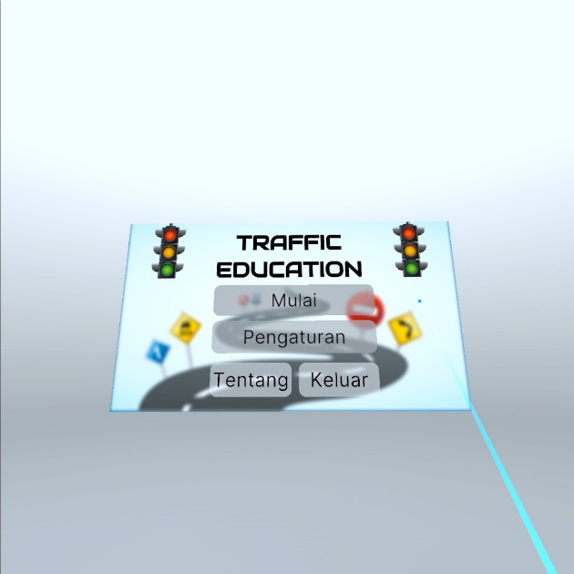 | 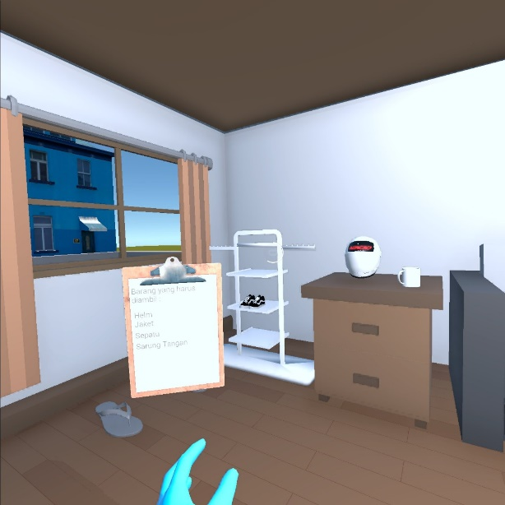
Figure 2. VR initial view (left) and collecting riding gear (right)

The second scenario played by players is driving and understanding traffic signs. There are three signs that will be passed, namely a red light where the player must stop, a yellow light to be careful, and a green light indicating to continue driving. Furthermore, the third scenario played by players in this VR game is the ethics of walking. Participants are asked to walk on the sidewalk with one row to the back.

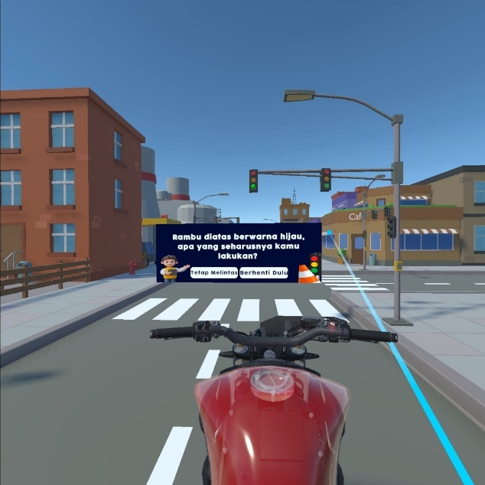 | 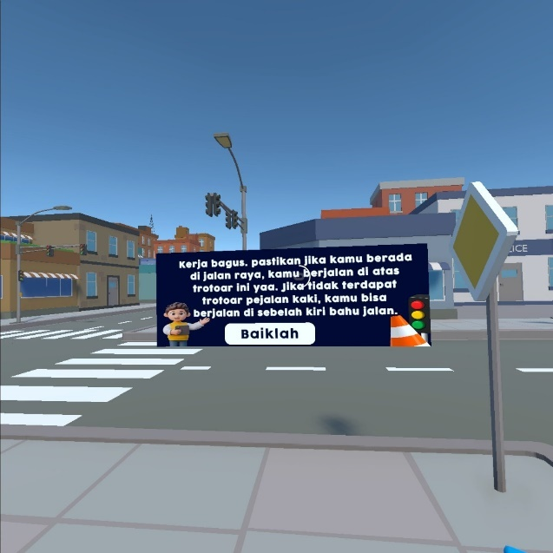
Figure 3. Knowledge of traffic lights (left) and practice of walking etiquette (right)

The last scenario in this traffic safety VR is the skill in crossing the road. In this scenario the player must cross at the zebra cross, look to the right and left before crossing, and giving signal by raising their hands before crossing.

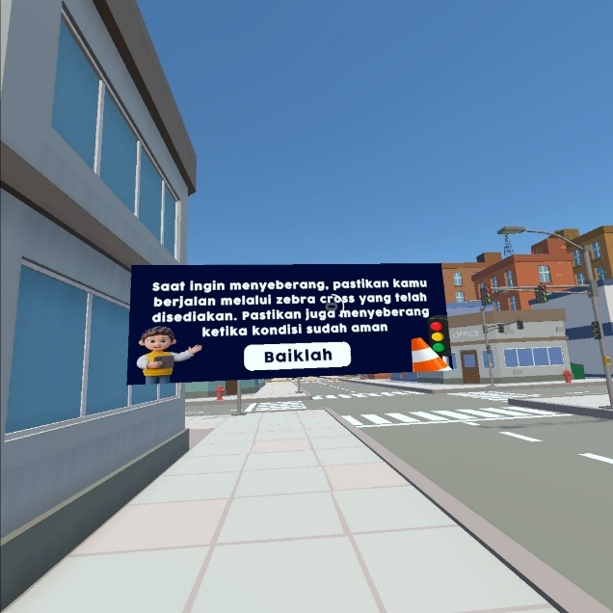 | 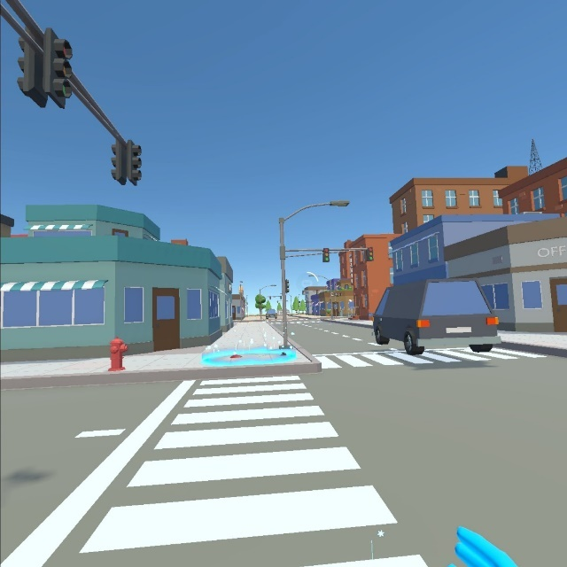

Figure 4. Practice crossing the road

Product Validity of VR Traffic Safety
Promotional media for traffic safety using VR has been developed, followed by product validity testing. Product validation was carried out by media experts, material experts, and Indonesian language experts. The experts used the assessment sheet that had been provided. The assessment of the experts received a score of 85.79 so that it can concluded that the promotional media for traffic safety media using VR is considered feasible for use in learning.

Table 1. The results of the expert validity test of VR traffic safety
No. | Assessed component | Percentage Value (%) | Category
1. | Media | 87,5 | Feasible
2. | Content | 85,94 | Feasible
3. | Indonesian language | 85,94 | Feasible
Total Value |  | 257,38 | -
Average |  | 85,79 | Feasible

The results of expert validity show that VR traffic safety is feasible to be implemented for elementary school students with some improvements: VR media is interesting for children, but if children have used it repeatedly it will cause boredom so that various scenarios with various levels of difficulty can be made.

Feedback
Students involved in the pilot test of the use of traffic safety promotional media using VR were very enthusiastic and very happy to try the VR traffic safety game. Most of them had never used VR before. They enjoyed the scenarios and tasks that they had to do, starting from collecting driving safety equipment, riding a motorbike and learning the traffic lights, walking on the sidewalk, and crossing the road at the zebra crossing. After trying out the VR some of the students had a good understanding of the equipment that must be used before riding and the meaning of traffic lights and they demonstrated their ability to cross the road.
Feedback from the teachers was also very good. They really appreciated that the traffic safety material taught was very useful and in line with the problem of unsafe behaviour that many children do, especially the behaviour of crossing the road carelessly. The teachers also emphasised that this type of activity is beneficial for children, especially at their age. They are very satisfied with this in-depth training procedure and highly recommend this type of activity for children in schools.
"Setting the traffic environment as real so that children learn happily” (teacher 2)
“Usually, we find it difficult to teach traffic safety material directly to children, for example, when children cross the road, we have to line them up and supervise them while crossing the road. With this VR game, the risk is lower but the learning is still realistic and fun for the children” (teacher 5).
With the various advantages of VR, teachers and students expressed challenges in using VR. The challenge of using VR for students is that they feel dizzy if they use VR for a long time. Meanwhile, for teachers, they do not have sufficient understanding of VR technology, as well as constraints in terms of funding because the procurement of VR equipment is quite expensive.
“We feel that we are not familiar with this VR technology. Besides, this VR tool is quite expensive, so schools may find it difficult to buy it” (teacher 1).

DISCUSSION
Our findings revealed that the unsafe behaviour that is commonly found in children is crossing the road suddenly. This is due to the impulsive instincts of children, and the lack of knowledge and understanding of traffic procedures (44). Young children have limited abilities in crossing the road, such as awareness of traffic rules, visual search skills, risk detection and perception. As these abilities are acquired with age and experience, younger children are more at risk (17,45–47). Children must avoid distracting activities that could cause them to ignore important environmental cues and cross within the lines of the crosswalk in order to cross safely (48,49).
The findings of this study are consistent with the study conducted by D.C. Schwebel and colleagues investigates the pedestrian behaviors of children crossing a busy street near a primary school in Changsha, China. The research highlights that children often cross without adult supervision, frequently ignoring safety advice and engaging in risky behaviors such as not checking for oncoming traffic (50). For a variety of reasons, kids may disregard safety precautions and participate in dangerous activities. One contributing aspect is the presence of adults, which may cause kids to assume they are safe since the adult will keep them safe. Children may disregard safety instructions as a result of this false sense of security. Furthermore, especially in the afternoon, children frequently cross streets with their friends rather than adults, which might result in hazardous behaviours such failing to check for traffic. The complexity of the cognitive-perceptual task of crossing a street, especially in dense traffic environments, can also contribute to risky behaviors, as children may struggle to quickly judge the speed and distance of oncoming traffic.
According to the findings of this study on the demands for traffic safety education materials, four things must be taught: safe driving equipment, traffic lights, sidewalk walking and crossing techniques. The analysis of educational content aligns with those of several other nations. Understanding traffic signs and wearing a helmet when driving are two safety education strategies that are advocated in Cambodia (51). In Saudi Arabia, elementary school pupils are taught road safety through the use of cell phones while driving, seat belt use, blind spots, safe distances, and traffic signs (52). Students' understanding of traffic safety improved because to the useful teaching resources offered. The educational materials provided proved to be effective in improving students' knowledge of traffic safety.
The results of this study indicate that VR traffic safety education is feasible to be implemented in elementary schools. Thus, schools can integrate traffic safety education into the learning curriculum. In addition, schools need to provide training for teachers related to VR technology so that they understand and are familiar with how to operate VR. Stakeholders such as the education office are expected to support the implementation of VR traffic safety education with policy and budget support for the implementation of traffic safety education using VR in schools, establish cooperation with technology companies to support the application of VR technology in schools, and increase awareness of the use of VR for traffic safety education widely to schools and the community.
Teachers and students gave positive feedback on the advantages of using VR. The VR system allows children to engage in realistic simulations where they can practice road safety exercises without the risk of real-world dangers. This setup uses a 3D realistic virtual city with intelligent traffic systems, enabling children to learn and practice traffic rules in a controlled environment. Additionally, the use of VR has been shown to significantly enhance children's learning skills, allowing them to transfer improved behaviors from the virtual environment to real-world situations (53). Study by (54) evaluated the effectiveness of VR environments in teaching children aged 7-12 how to cross streets safely, finding that VR training significantly improved street crossing skills in both virtual and real-life scenarios. These findings suggest VR simulations can be a valuable tool in improving pedestrian safety skills among children.

Limitations and Cautions
The limitation of this study is that the pilot test was limited to 5 schools in Yogyakarta Special Region. It is recommended that traffic safety education using VR can be applied more widely in other cities in Indonesia that have a high number of traffic accidents. A further limitation of this study is that the scenarios developed are still simple and limited to four traffic safety skills. The weakness of VR is that it can cause motion sickness, so it is recommended for users if they feel dizzy to stop using it immediately.

Recommendations for Future Research
For future research, it is expected to develop more complex VR Traffic Safety Education scenarios such as cycling to school, being a passenger in a car, crossing railroad tracks, etc.

CONCLUSION
Traffic safety education needs to be taught to children as early as possible. Learning traffic in a real environment setting is very difficult and can be dangerous for children. Learning with VR technology is very beneficial. The unsafe behaviour of children on the road is crossing the road suddenly and running. Thus, we designed a VR game to simulate traffic safety knowledge and skills. There are 4 scenarios trained in this VR which are; pre-driving equipment, traffic lights, how to cross the road, and walking etiquette. The VR traffic safety product has obtained valid test results from the validity test with material experts, media experts, and language experts. The advantage of using VR is that the learning process becomes interesting for children. Further study can be improved by adding more complex scenarios, such as more difficult activities like bicycling, securely crossing a railway, and many more. To scale up the implementation of traffic safety education using VR more widely in Indonesia, the main steps that are urgent to do are policy support and funding from the ministry of primary and secondary education, making standard operational procedures for developing VR traffic safety education, infrastructure support, cooperation and collaboration with technology companies, training and awareness campaigns.

AUTHOR’S CONTRIBUTION STATEMENT
All authors confirmed their contributions to the paper as follows: The first and second authors drafted the proposal and designed the project, the third and fourth authors developed the Virtual Reality application, the first and second authors conducted Virtual Reality testing, data collection and analysis. The second author wrote the draft manuscript. The third and fourth authors supervised this work. All authors discussed the results and contributed to the final manuscript.

CONFLIC OF INTEREST
I declare that I have no conflicts of interest related to this study. I have no personal or financial relationships that could influence my work.

SOURCE OF FUNDING STATEMENT
This research was funded by the Ministry of Education, Culture, Research and Technology of the Republic of Indonesia under contract number: 107/E5/PG.02.00.PL/2024,0609.12/LL5-INT/AL.04/2024, 134/PFR/LPPM-UAD/VI/2024

ACKNOWLEDGEMENT
The authors would like to thank: 1. The Ministry of Research, Technology and Higher Education for funding this research, 2. LPPM UAD for support, monitoring and supervision in the implementation of this study.

BIBLIOGRAPHY
1. World Health Organization. Global Status Report on Road Safety. 2018.
2. Kusumastutie NS, Patria B, Kusrohmaniah S, Hastjarjo TD. A review of accident data for traffic safety studies in Indonesia. IOP Conf Ser Earth Environ Sci. 2024;1294(1).
3. Jusuf A, Nurprasetio IP, Prihutama A. Macro data analysis of traffic accidents in Indonesia. J Eng Technol Sci. 2017;49(1):133–44.
4. Hardimansyah R, Putro H, Rokhim A, Rahmita D. Accident Prone Area Database Analysis in Yogyakarta City. RSF Conf Ser Eng Technol. 2022;2(2):247–55.
5. Balitbangkes RI. Laporan Riskesdas 2018 Nasional.pdf. Lembaga Penerbit Balitbangkes. 2018.
6. Masuri MG, Isa KAM, Tahir MPM. Children, Youth and Road Environment: Road Traffic Accident. Procedia - Soc Behav Sci. 2012;38(December 2010):213–8.
7. Vu AT, Man Nguyen DV. Analysis of Child-related Road Traffic Accidents in Vietnam. IOP Conf Ser Earth Environ Sci. 2018;143(1):1–10.
8. Goniewicz K, Goniewicz M, Pawłowski W, Fiedor P, Lasota D. Risk of road traffic accidents in children. Med Stud. 2017;2:155–60.
9. Backett EM, Johnston AM. Social patterns of road accidents to children: Some characteristics of vulnerable families. Inj Prev. 1997;3(1):57–62.
10. Singh D, Singh SP, Kumaran M, Goel S. Epidemiology of road traffic accident deaths in children in Chandigarh zone of North West India. Egypt J Forensic Sci. 2016;6(3):255–60.
11. Ohnishi H, Fujiu M, Morisaki Y, Takayama J. Fundamental Analysis of the Ages of Children and Road Structures Involved in Traffic Accidents. Sustain. 2023;15(19).
12. Lee YY, Fang E, Weng Y, Ganapathy S. Road traffic accidents in children : the ‘ what ’, ‘ how ’ and ‘ why .’ 2018;59(4):210–6.
13. SOEHODHO S. Motorization in Indonesia and Its Impact To Traffic Accidents. IATSS Res. 2007;31(2):27–33.
14. Hasriantirisna. Relationship Between Knowledge and the Incidence of Chronic Energy Deficiency in Pregnant Women. J Public Heal Pharm. 2023;3(1):1–4.
15. Islam F, Ahmad H, Nurbaya, Ahmad M, Ansar, Ramadhan K, et al. Factors Affecting Treatment Adherence Among Patients with Tuberculosis in Indonesia: Literature Review. J Public Heal Pharm. 2024;4(1):28–37.
16. Wartana IK, Kolupe VM, Fajrah S, Rikwan, Gustini. Community Behavior to Prevent Covid-19 and its Associated Factors in North Parigi District. J Public Heal Pharm. 2024;4(1):90–7.
17. Tansile SN, Amalinda F. Evaluation of the Toddler Family Development Activity Group. J Public Heal Pharm. 2023;3(3):55–7.
18. Lipu AYB. Factors that Play a Role in Community Participation in Creating Healthy Alleys in Makassar City. J Public Heal Pharm. 2023;3(2):40–6.
19. Waters S, Baker S, Bruce K, Lindner H, Clarkson E. Looking both ways: The intersection of road safety education and early childhood research. Australas J Early Child. 2014;39(1):102–12.
20. Sudirman, Ali MN, Rahman N. Influence of Social Determinants of Health Service Quality on Patient Satisfaction at Undata Hospital, Palu. J Public Heal Pharm. 2024;4(2):113–22.
21. Herawati, Baculu EPH. Correlation of Knowledge and Public Attitude With Vaccination Covid-19 Injection at Sub-Discrit Tuwelei of Tolitoli Regency. J Public Heal Pharm. 2022;2(3):55–8.
22. Diana. Competence of Public Health Center Health Extension Officers in the Tual City Health Service Work Area. J Public Heal Pharm. 2023;3(2):29–35.
23. Alonso F, Esteban C, Useche S, Colomer N. Effect of road safety education on road risky behaviors of spanish children and adolescents: Findings from a national study. Int J Environ Res Public Health. 2018;15(12):1–15.
24. Alimohamadi Y, Sepandi M. Intervening young children with road safety education yields reduction in road crashes Kulanthayan. Tabriz Univ Med Sci. 2019;11(1):78.
25. Li Q, Tay R. Improving drivers’ knowledge of road rules using digital games. Accid Anal Prev. 2014;65:8–10.
26. Li Q, Tay R, Pustaka A. Let Us Save Lives Using Games! A Study of the Effect of Digital Games for Traffic Education. J Educ Technol Syst. 2020;49(2):199–218.
27. Fatmawaty, Rahman MA. Naming Diseases in Children by the Sidrap Bugis Ethnic. J Public Heal Pharm. 2023;3(2):47–54.
28. Tombeg Z, Yetti RE, Hadi AJ, Hasibuan AS, Rate S, Handayani FR, et al. Determinants of the Incidence of Acute Respiratory Infections (ARIs) in Children Under Five at the Getengan Community Health Center, Tana Toraja Regency. J Public Heal Pharm. 2024;4(1):10–8.
29. Muhamad Z, Nurdin SSI, Asnidar, Abbas MI, Katili DNO. Family Support for Short-Status Pregnant Women to Prevent Gestational Stunting: Phenomenological Studies. J Public Heal Pharm. 2024;4(2):182–8.
30. Schwebel DC, Combs T, Rodriguez D, Severson J, Sisiopiku V. Community-based pedestrian safety training in virtual reality: A pragmatic trial. Accid Anal Prev. 2016;86:9–15.
31. Halabi O. Immersive virtual reality to enforce teaching in engineering education. Multimed Tools Appl. 2020;79(3–4):2987–3004.
32. Covaci A, Ghinea G, Lin CH, Huang SH, Shih JL. Multisensory games-based learning - lessons learnt from olfactory enhancement of a digital board game. Multimed Tools Appl. 2018;77(16):21245–63.
33. Wang P, Wu P, Wang J, Chi HL, Wang X. A critical review of the use of virtual reality in construction engineering education and training. Int J Environ Res Public Health. 2018;15(6).
34. Belmonte LM, García AS, Morales R, de la Vara JL, de la Rosa FL, Fernández-Caballero A. Feeling of safety and comfort towards a socially assistive unmanned aerial vehicle that monitors people in a virtual home. Sensors (Switzerland). 2021;21(3):1–30.
35. Szczurowski K, Smith M. ’Woodlands’-A Virtual Reality Serious Game Supporting Learning of Practical Road Safety Skills. 2018 IEEE Games, Entertain Media Conf GEM 2018. 2018;427–35.
36. Zare H, Niknami S, Heidarnia A, Hossein Fallah M. Traffic safety education for child pedestrians: A randomized controlled trial with active learning approach to develop street-crossing behaviors. Transp Res Part F Traffic Psychol Behav. 2019;60:734–42.
37. Purcell C. Teaching children road safety using a simulated environment. J Educ Educ Dev. 2020;7(1):44.
38. Suparmanta S. Analisis Kecelakaan Lalu Lintas Yang Terjadi Pada Anak-Anak studi kasus : Daerah Istimewa Yogyakarta. J Penelit Transp Darat. 2019;20(2):107.
39. Duperrex O, Bunn F, Roberts I. Safety education of pedestrians for injury prevention: A systematic review of randomised controlled trials. Br Med J. 2002;324(7346):1129–31.
40. Box E, Dorn L. A cluster randomised controlled trial (cRCT) evaluation of a pre-driver education intervention using the Theory of Planned Behaviour. Transp Res Part F Traffic Psychol Behav. 2023;94(January):379–97.
41. Sugiyono. Metode Penelitian Kuantitatif, Kualitatif, dan R&D. 2 cetakan. Sutopo, editor. Bandung: Alfabeta; 2021.
42. Thiagarajan S, Semmel DS, Semmel MI. Instructional development for training teachers of exceptional children: A sourcebook. Bloomington: ERIC; 1974.
43. Kr P. Application of Colaizzi’s Method of Data Analysis in Phenomenological Research. Med Leg Updat. 2021;(September).
44. Sugiyanto G, Santi YM. Pendidikan Keselamatan Sejak Usia Dini Untuk Mengurangi Tingkat Fatalitas Pejalan Kaki. J Tek Sipil. 2016;13(2):104–13.
45. Widasari L, Hadi AJ, Ahmad H, Setyalaksana W, Damayan L, Sutrisni E. Structural Model for Preparing Safe and Hygienic Complementary Food in Indonesia. J Public Heal Pharm. 2024;4(2):189–98.
46. Muhamad SS. Emotion Regulation and Impulse Control of Child Victims of Sexual Harassment in Makassar City. J Public Heal Pharm. 2023;3(1):15–9.
47. Kartini. Relationship between Diet and Family Income with Malnutrition in Toddlers in the Working Area of Mamajang Health Center, Makassar City. J Public Heal Pharm. 2021;1(2):30–3.
48. Schwebel DC, Stavrinos D, Byington KW, Davis T, O’Neal EE, De Jong D. Distraction and pedestrian safety: How talking on the phone, texting, and listening to music impact crossing the street. Accid Anal Prev. 2012;45:266–71.
49. Tapiro H, Oron-Gilad T, Parmet Y. Cell phone conversations and child pedestrian’s crossing behavior; a simulator study. Saf Sci. 2016;89:36–44.
50. Schwebel DC, Wu Y, Swanson M, Cheng P, Ning P, Cheng X, et al. Child pedestrian street-crossing behaviors outside a primary school: Developing observational methodologies and data from a case study in Changsha, China. J Transp Heal. 2018;8(January):283–8.
51. Mark Lee S, Al-Mansour AI. Development of a new traffic safety education material for the future drivers in the Kingdom of Saudi Arabia. J King Saud Univ - Eng Sci. 2020;32(1):19–26.
52. Thomson JA, M.Whelan K. Project Report a Community Approach to Road Safety Education Using Practical Training Methods : The Drumchapel Project. 1997;
53. Khan N, Muhammad K, Hussain T, Nasir M, Munsif M, Imran AS, et al. An adaptive game-based learning strategy for children road safety education and practice in virtual space. Sensors. 2021;21(11):1–22.
54. Bart O, Katz N, Weiss PL, Josman N. Street crossing by typically developed children in real and virtual environments. OTJR Occup Particip Heal. 2008;28(2):89–96.

